|  |  |  |
| --- | --- | --- |
|  |  | schutz and maslow’s theory needs  SSG103  2nd Assignment |

__________________________________

|  |  |
| --- | --- |
| *Name* | **TRẦN THANH DƯƠNG** |
| *Student’s Code* | **SE160185** |



# Schutz’s interpersonal needs theory

William Schutz proposed the **Fundamental Interpersonal Relations Orientation (FIRO)** theory of interpersonal relations in 1958. This idea explains how a group of individuals interact with one another.

There are 3 needs he discussed were the need for:

* Inclusion – the need for belonging (or the need to be part of a group of people)
  + Oversocials: don’t want to be ignored or outside of a group.
  + Undersocials: want to be left alone.
* Control – the need to maintain power and influence.
  + Autocrats: refer people who are self-driven and responsible.
  + Abdicrats: refer the followers who look to other direction.
  + Democrats: refer people who fall in the middle, looking to get things done through teamwork.
* Affection – the need for recognition.
  + Underpersonals: shy from interactions.
  + Overpersonals: have strong need for interactions.

# dicuss two characters from film/movie – HARRY POTTER AND TOM RIDDLE (VOLDEMORT)

|  |  |  |
| --- | --- | --- |
|  | **HARRY POTTER** | **TOM RIDDLE (VOLDEMORT)** |
| **INCLUSION** | Harry was shunned since childhood and mistreated by his aunt and uncle because he was considered a danger to everyone around him, due to that reason he always yearned to find a place where he belonged, and Hogwarts was one of them. In Hogwarts, everyone respected Harry and he also found two of his best friends: Ron and Hermione. | Like Harry, Tom was also an inauspicious child when his father abandoned his mother when she was pregnant. But unlike Harry, he didn’t want to play with anyone and want people left him alone. |
| **CONTROL** | Harry Potter was a person who looked to get things done through teamwork. He was humble and brave, so that sometimes he was a driven person in some dangerous situations, and a person who knew to listen. | Tom was the typical character for a brutal dictator. He feared death, so he used a lot of ruthless methods and without inability to love or trust anyone, just for his ambition to be immortal. |
| **AFFECTION** | Harry always wanted people to see him as HARRY POTTER, not a **second Voldemort**. He really liked to chat with everyone and wanted to prove that he wouldn’t bring threats to them like Voldemort. | He had no affection from anyone and didn’t try to make everyone love him. Because of the painful past, he really hated everyone around him. He had no love, no conscience, no mercy and no stopping his ambition to be immortal. |

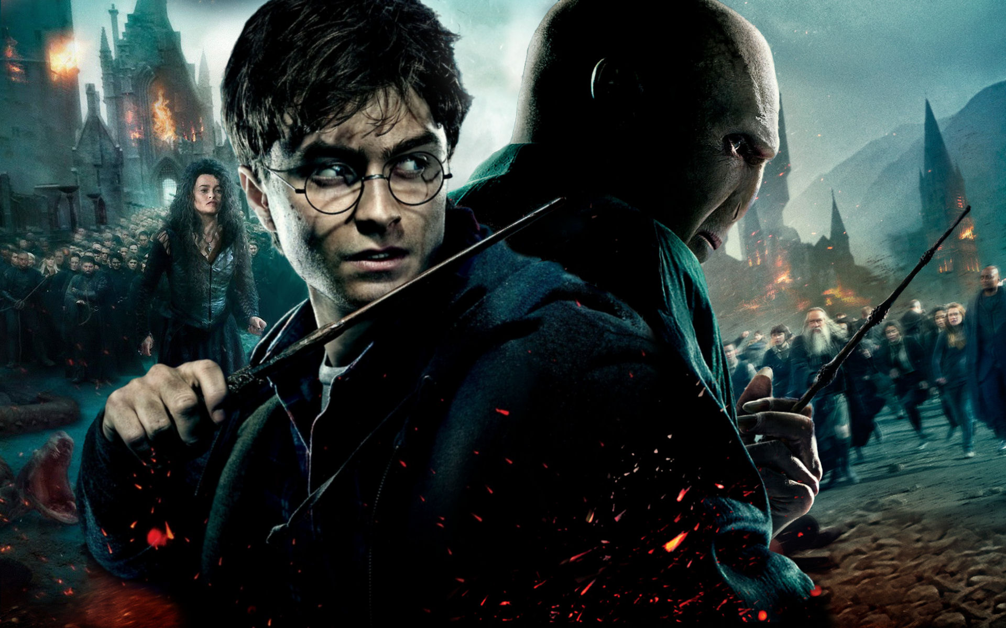

[This Photo](https://mike1306.deviantart.com/art/Harry-and-Voldemort-253320357) by Unknown Author is licensed under [CC BY-NC-ND](https://creativecommons.org/licenses/by-nc-nd/3.0/)

# maslow’s hierachy of needs

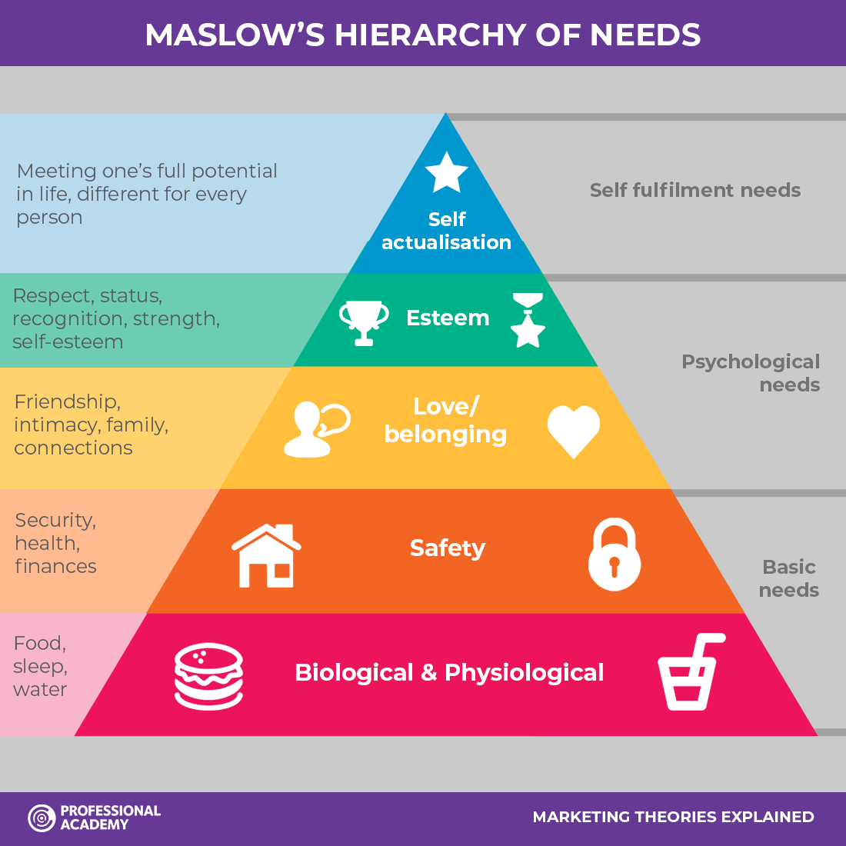

**Maslow’s hierarchy of needs** is a motivational theory in psychology comprising a five-tier model of human needs, often depicted as hierarchical levels within a pyramid.

1. **Physiological needs**: These are necessities for human life, such as air, water, food, sex, and clothes.
2. **Safety needs**: In their daily lives, individuals seek order, predictability, and control. These requirements can be met by the family and society (e.g., police, schools, hospital)
3. **Love/belonging needs**: Social needs are the third level of human wants, and they include feelings of belonging. Belongingness is a human emotional need for interpersonal interactions and a sense of belonging to a community.
4. **Esteem needs**: Achievement and respect are the fourth. Respect is the most fundamental requirement for children and adolescents, and it comes before true self-esteem or dignity.
5. **Self-actualization needs**: Are the fifth and highest level in Maslow’s hierarchy, and refer to the realization of a person’s potential, self-fulfillment, seeking personal growth and peak experiences.

## Two characters have the same action but different needs – Naruto vs. Sasuke

|  |  |  |
| --- | --- | --- |
| **CHARACTER**  **ACTION** | **NARUTO** | **SASUKE** |
| Want to be the best ninja | This is esteem needs, he wanted to receive respect and recognition from everyone. Also, his passion is to become a Hokage – the best ninja in a village. | He wanted to revenge on his brother because his brother killed the entire Uchiha clan. This is his greatest purpose depending on lack of love/belonging needs. |
| Stay away from people voluntarily | He knew his hidden power could be harmful to people, he wanted to keep safe for everyone and for himself. This is his basic needs. | He wanted to hide his weakness in emotion to everyone. This is his safety needs, he wanted to keep private. |
| Married | Naruto married Hinato depending on real love. Another reason is he was lack of family love since he was born. This is love/belonging needs that he wanted to be happy with his lover. | Sasuke and Sakura married for love, but there was another big reason for him to marry: children. Sasuke is the last surviving Uchiha clan member. He wants his family to live on, he has to produce children. This is his biological and psychological needs. |

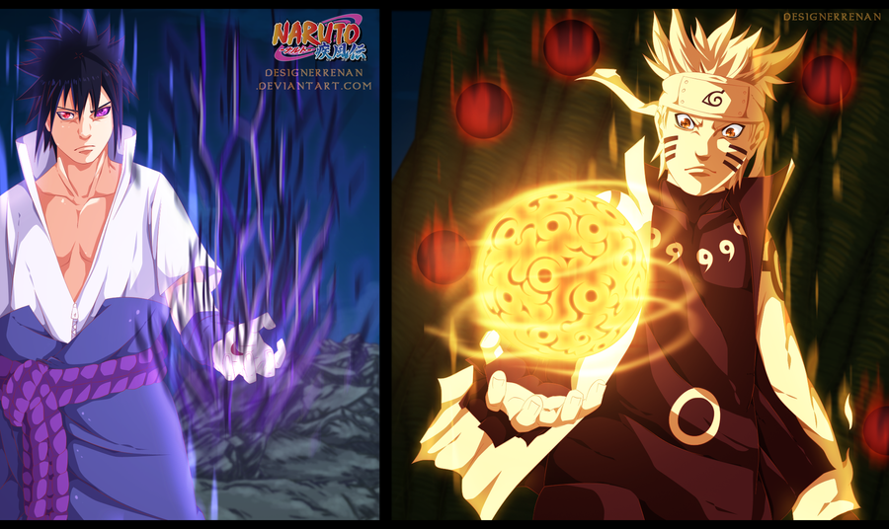

[This Photo](https://designerrenan.deviantart.com/art/Naruto-674-double-attack-449640191) by Unknown Author is licensed under [CC BY](https://creativecommons.org/licenses/by/3.0/)